CIS 726 Advanced WWW Technology

Project Final Report

726TV : Online TV

http://cursa.cis.ksu.edu:7024/servlet/Homepage

To connect with no registration:
Email : guest
Password: guest

By

Nick Sanders

Walamitien Oyenan

JinMin Fu

Instructor: Dr. Daniel Andresen

May 16, 2002

I. Introduction
726TV is a web site to stream movies in real-time. It uses the television paradigm, where the movies are streamed continuously. The broadcasts are divided into channels, based on the movie’s genre. The movies are scheduled weekly and may be played several times a week. Users that are connected will all watch the same movie at the same time according to the channel to which they are connected. Although movies are pre-recorded, it is not a video-on-demand system. The streaming server used will stream those movies in one stream. This obviously supposes a multicasting-enabled network. As is the case with the Internet, our primary base of clients, does not support multicasting. Therefore the web site will only be able to support a fixed number of clients. Our expected clients should have a broadband connection in order to receive movies streamed. Others users, will only be able to browse the site and watch trailers. Another feature that the web site offers is to have a movie store where users can buy/download some movies, although it has not been implemented.
In addition, the site works best with Internet Explorer 5.5 and above. Users of other browsers will experience reduced functionality due to lack of XML support in other browsers. For handicapped access, we have provided a link to a text-only page with all relevant links. We have also included descriptions of images in the alt tags.

II. Network Diagram
The network diagram shows network connectivity for the web site. We can assume that the streaming server will stream over a multicasting enabled network. A real streaming scenario will be discussed in the section about the streaming server. Therefore, we chose Gigabit Ethernet for the connectivity to the streaming server. No computation is required at the stream movie. A minimal configuration will be used for this server. Movies are stored on network attached storage connect to the server. If we store movies of about 500MB (rate of 400Kbps), we will need 10TB to store all our actual 20000 movies.
Some computation is required on the web server. It needs to generate dynamic content in response to users request. We also estimate that each page is 100K. Actually, clients won’t have to download 100K at each request because we are reusing pictures that will be cached on the clients’ computer. With this consideration, we estimate that we need a Fast Ethernet connection (10 Mbps) to the web server.

NETWORK DIAGRAM
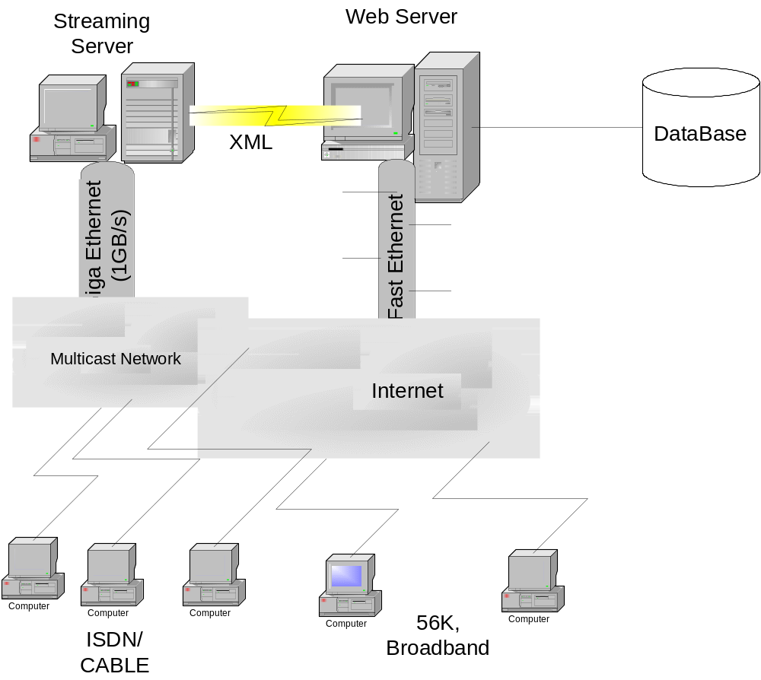

The configuration on the server will be:
- Dual Pentium III processor
- 256 MB ram
- 20 GB Hard Drive
The users we expect to connect will have high-speed connections with a bandwidth of at least 300 kilobits per second, such as cable or DSL. We do not provide special streams for users with 56 kbps and slower connections. Video quality at those would be extremely poor and would probably not be enjoyable to watch. The clients’ computers must be powerful enough to run the QuickTime 5 player, which requires, at least, a Pentium-class CPU and 32 megabytes of RAM. We do not support streaming technologies other than QuickTime. To fully experience the site, the users will need the Macromedia Flash 5 plug-in, although we do support browsers without Flash. The clients should also have JavaScript enabled in their browsers.

III- Database Connectivity
The database software we have chosen to use for this project is MySQL. We chose MySQL because, according to tests conducted by PC Magazine, it offers performance on par with Oracle9i and it is freely available (Dyck). We do not believe, however, that MySQL would be sufficient if we were to actually implement this site. It lacks many useful features that would be beneficial in an actual implementation. The backup system does not allow for incremental backups, there is no standard GUI interface, and configuration requires manual editing of files.
If we were going to actually implement this site, we would probably choose Oracle9i. Although it is expensive at $40,000 per CPU, it offers high-performance, graphical configuration, a standard GUI interface, and direct support for XML through Java APIs. Description of the fields of the tables and links between tables are described in Appendix A.
Updating the database is accomplished primarily with Java servlets and classes, although new movies are added to the movie table manually. The user table is updated with new customer information with the AddCustomer servlet. This servlet is invoked by clicking submit on the registration page. When invoked, the servlet checks that all the fields in form have been filled in and the password and password verification fields match. If these conditions are met, the data is inserted into the user table. If these conditions are not met, the servlet returns a page that indicates what the problem is and a link back to the registration form.
The movies and schedule tables are updated using Java classes. The Schedule class uses a DOM tree to create an XML weekly schedule file by retrieving movies from the database based on rules we have created as to which movies should be shown. The Playlist class creates a Darwin Streaming Server compatible playlist based on the information.
The performance of MySQL should be on par with Oracle. The performance of the database depends on several factors: bandwidth, database schema, host speed and RAM, and database optimizations. The performance of our database is somewhat slower than we expected. This could be due to network congestion in the dorms or a database schema that is not optimal. Our tables are small enough to be held in the available RAM, so they can be accessed quickly. Creating table indexes increased performance, but it is still slower than we would like.

IV. Streaming Server
For streaming the QuickTime video, we have chosen Darwin Streaming Server (DSS). It is the open-source version of Apple’s QuickTime Streaming Server. It is available for an array of platforms including Windows and Linux. The main reason we chose DSS is because it is free and provides excellent video quality compared with other streaming video technologies. We chose not to use HTTP streaming because in order to stream real-time video the network must have more bandwidth available than the bit-rate of the stream and we do not want the users to be able to save the video stream to their local hard drive.
DSS is a server technology that allows us to send streaming QuickTime data to clients across the Internet using the industry standard RTP and RTSP (Real Time Streaming Protocol) protocols. Real-time streaming allows the user to view long movies or continuous transmissions without having to store more than a few seconds of data locally. RTP uses UDP/IP protocol, which doesn't attempt to retransmit lost packets. This allows multicasts as well as live streams. These are both cases where retransmission would not be practical.
Our web site was intended to stream real time movie using the multicasting ability of DSS. However, not all routers support multicasting. For our clients that are behind networks with routers that don’t support multicasting, we envisioned different scenarios:
- We can buy enough bandwidth and servers to stream the movies ourselves. Additionally servers will be distributed around the country to be use as reflectors for the movie streams. DSS provides this capability.
- We can use some multicast service that would enable a single stream of content to be broadcast simultaneously to thousands of recipients. In this case, the bandwidth needed to stream will be minimal, i.e. just enough to fit to the size of the movie.

V. Web server
We are currently using Jigsaw from the World Wide Web Consortium as our web server. We chose Jigsaw because it is free and easy to setup and configure. In a real implementation, however, we would use Apache with Tomcat to handle the servlets. There are several reasons for this. First, Apache and Tomcat are more mature and robust. Second, Apache and Tomcat are more widely used, so information and support should be more readily available. Third, Jigsaw is more of a technology demonstrator than an actual production web server (Open-source). Fourth, Jigsaw does not currently support SSL, which would be needed in a real implementation. Finally, Tomcat offers better performance than Jigsaw (Open-source).

VI. Implementation
The graphics used in the web sites have been downloaded from the Internet. We used Photoshop to modify them in order to fit well with the overall design. The site has been designed to be fit in an 800x600 screen resolution. During the design process, we were confronted with some browser compatibility problems. Two principal browsers have been used to test the design: Internet Explorer 5, Netscape 4, and Mozilla/Netscape 6. These represent the major browsers presently used. At first, we mostly used background images in our pages that were designed with FrontPage. However Netscape 4 does not support background images. We could have simply used background colors to create a decent design the looked good on all the browsers. Instead, we decided to keep our design for IE and use CSS to display some other graphics that would render the sites correctly under Netscape. All the graphics used for the layout are very small at less than 2K and will not impact the download time noticeably.
Most of the animation effects in the web site have been created via CSS 2.0. With CSS, we have more freedom in manipulating the object in the layout and we can decide whether or not they should appear in the page. On the Home page, the tab panel displays the movies of the day and the top ten movies is a superposition of two tables. Only one is displayed at a time. The same technique is applied for changing a movie’s description when the users move over a movie image on the homepage. Internet Explorer and Netscape are CSS compliant but there is a lot of bugs reported. And bugs are different for each browser’s version. We used a nice document from CSS Pointer Group (http://css.nu/pointers/bugs.html), reporting all CSS bugs known, in order to find some workarounds. For now, CSS effects have only been tested under IE5, IE6 and Netscape 4.7 and work well. Some improper and unpredictable behaviors have been experienced under Netscape 4.0.
Another problem was the browser tolerance of certain types of html errors. A missing tag in IE may not affect the display while in Netscape it can be devastating. There is also some confusion about which tags are required to be closed. An unclosed <p> tag under Netscape prevents all CSS instructions from working. All our pages have been primarily designed in HTML before being implemented with XSL. In XML, all the tags, including <br> and <img>), need to be closed.
Our website takes into consideration the handicap access issue and handles it well. We have made provision in our website for this issue by giving “alt tags” wherever an image appears and avoiding small clickable objects.

Description of the Pages

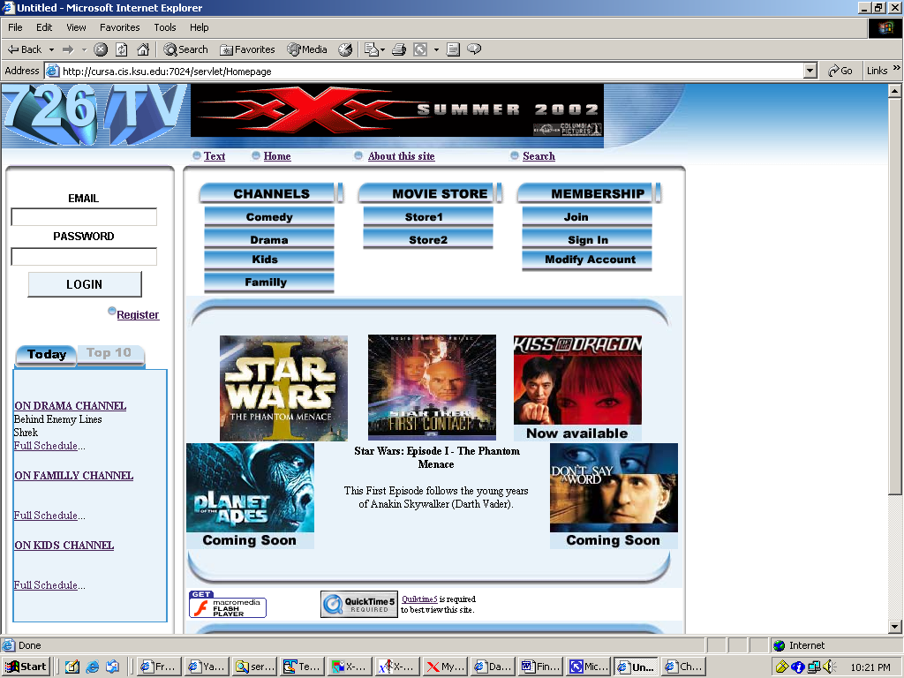
Figure 0: The homepage

Homepage
The home page is generated by the servlet Homepage. This page contains a tab panel showing some of today’s movies in each channel and the top 10 list. This page also contains a Flash menu used for accessing the various service of the web site. We do not, however, require the user to have Flash. An alternative HTML menu will be displayed if the Flash plug-in is not detected. In this page, we also advertise some of our new movies (upcoming movies, new available movies in the store and new movies playing this week).
Users will be given links to download QuickTime and Flash plug-ins. Recall that QuickTime is required to view the videos (live movies and trailers).

Movie Page
The movie page is dynamically generated and contains information about a movie. It can be accessed either via the search page by clicking on the title of the movie or any of the movie images on the site. This page displays the full movie summary in a scrollable TV-like window. In this window, the user can also view the trailer of the selected movie by choosing the trailer size according to his bandwidth. Three trailer sizes are available:
- Small for dial-up connection
- Medium for mid-range speeds between 56 kbps and 300 kbps
- Larger for broadband connection.
From this page, the user can either go back to the search page by clicking on “Search All Movies” or directly launch a search for movies in the same genre by clicking on “View More In This Genre”. This last feature of the page has not been implemented yet.

Drama page
This page contains a tab for viewing all the movies of the day in this channel. It also displays a picture of the movie being played at this time. Clicking on this picture will automatically open the QuickTime player and establish a live connection with the streaming server. Only a user who is logged in can access this feature. Other users will be redirected towards a login/registration page. There is also a remote control that would allow user to change channels (up/down) and see what movies are playing later (left/right). This feature has not been completely implemented.

Search page
To attract more people to visit a site, the site should provide the users with enough information about what they are looking for, and the process must be simple and quick for the user. For this site, we provide multiple ways for user to do the search. For example, people can search by title, year, channel, producer, company and genre. After one or all of above information is input, the movies that satisfy are brought to the client in XML format and formatted into a table. In this way, the client can manipulate the data as he wants. However, Netscape 4 does not support client side XML processing. For users using Netscape, we plan to send each request for data manipulation on the server. This feature has not been implemented yet.

Schedule page
The Schedule page was build by using XML/XSL technology. Data is extracted from database server, formed into DOM tree, formatted using an XSL stylesheet and sent to client. The Schedule page displays information about the movies, such as date, time, title, channel, rating, length and genre. The movie information will be listed in a table. Clicking on title of each movie will automatically open a summary page of this movie. Users can get more detailed information and can also rate this movie by using the summary page.

Java Design
The class diagram is shown in appendix B.

Servlets
Our web site uses servlets to dynamically serve page requests by the clients. Each page is generated by its own servlet. Some servlets require parameters (e.g. the Search and MovieInfo servlets) and some do not (e.g. the Homepage and Dramapage servlets). Each servlet uses the user’s session ID to determine if he is logged on and displays a calendar in place of the login section. We are also using Session tracking for the movie store and to associate an agenda for each user. Note that this feature has not been implemented. The following diagrams show the process of a client request:
Vector
HTML
XML
ResultSet
Request
Request
Client Browser
Servlet
(Homepage)
XSL
(DomTransformer)
DOM Tree
(HomeDom)
Data
(Data)
DBM
(DatabaseManager)
DB

Figure 1

Along with the servlets serving pages, we also have a registration servlet to update the database when a user registers and a login servlet to check and validate the users’ username and password. The implementation of this servlet will be discussed in the security section.

Data
This class transforms a ResultSet into a Vector-like object. We implemented methods like hasMoreRow(), getRow(), getValue() to easily manipulate ResultSets.

DomTransformer
This class uses a DOM tree to output either XML or HTML if an appropriate stylesheet is passed.

Database Manager
This class establishes the connection to the database and executes all the queries (update, insert or select) used in the web site.

QueryFactory
This class contains static Strings defining the SQL queries used in the web site. With this class, we can easily edit or create queries without having to modify the servlets.

Playlist
After the movies for the week have been chosen, the Playlist object reads the XML file produced and converts it into a play list that is readable format for the streaming server. A play list is a file containing the names of the movies in the play list along with some other information about how movies will be played, e.g. sequentially. The streaming server will stream all movies in the play list in the order they appear.
The Playlist object uses a SAX validating parser to parse the XML file made by the Schedule object.
ex: schedule.dtd
<?xml version='1.0' encoding = 'ISO-8859-1'?>
<!ELEMENT schedule (day+) >
<!ELEMENT day (name,movie+)>
<!ELEMENT name (#PCDATA) >
<!ELEMENT movie (id,title,filename,length,start,end)>
<!ELEMENT id (#PCDATA)>
<!ELEMENT title (#PCDATA)>
<!ELEMENT filename (#PCDATA)>
<!ELEMENT length (#PCDATA)>
<!ELEMENT start (#PCDATA)>
<!ELEMENT end (#PCDATA)>

Schedule
The schedule object is a class that produces the schedule of the week. We are choosing movies according to different slots of time. Typically, the slot from 7:00 PM to 1 AM is where we expect to receive most of our audience. Therefore, the movies played at this time are better. For now, the heuristic used to determine the best movies is simply based on the age of the movies. But some more accurate heuristic can be implemented. We can, for instance, consider the number of users connected to see the movie, its average rating, and the number of times it has been shown.
Movies in each slot can be shown several times during the same week. It actually depends on the number of movies selected to fill the time slots. For example, we put in a circular queue five “good” movies to be shown during the week. Every day, we select just four of them in the queue. This process allows us to have a good partitioning of movies where each movie is shown at various times and not every day during the week. To reduce the frequency at which movies are shown, we put more movies in the queue.

Schedule Update
The ParseSchedule object is used to update the database’s schedule table with a new weekly play list. It reads in the schedule.xml file, which is generated by the Schedule object. It then parses the schedule using the SAX validating parser and inserts the data into the appropriate fields in the schedule table. The ScheduleParser also updates two fields in the movie table: timesshown and lastshown with the appropriate values.

Scripts

Browser detection
To have a cross-browser compatible web site, we implemented browser detection in JavaScript that allows us to detect various browsers and their versions and deal with the particular case (cf design).

Plug-in Detection
Two plug-ins are used in the web site: QuickTime 5 and Flash. We are using plug-in detection to provide an alternative solution, in the case of Flash, or to redirect users toward a page where they can download the necessary plug-in, in the case of QuickTime. Both scripts are done in VisualBasic script because plug-in detection is difficult (may be impossible) in JavaScript.
CSS Scripts
Most of the scripts we wrote are in JavaScript and are related to CSS. We mostly used CSS 2.0, which is for object positioning. We used JavaScript to dynamically change the position of the pictures and text in the pages. Not only did this technique prevent us from dealing with embedded tables, but it also allowed us to provide some good effects like the tab panel, the changing text description (home page) for the featured movies, and the alternate design for Netscape Navigator. Problem related to CSS have been discuss in the design section of this report.

Maintenance
A new play list is started every week on Sunday at midnight. This is accomplished automatically through the use of Unix cron jobs. The Schedule object in invoked to create a new weekly schedule. The Playlist object is then run to create the play list for the streaming server. The ParseSchedule object reads the schedule and updates the database. Finally, the play list is started using the PlaylistBroadcaster program that is part of DSS. It takes the play list file as an argument and starts the QuickTime stream. The cron job to start the play list is as follows:

0 0 * * 0 cd /var/streaming/playlists/; /usr/local/bin/PlaylistBroadcaster -f
-a test/test.config

The 0 0 * * 0 indicates that the program is to be invoked on the 0th day of the week at the 0th hour and 0th minute, which is Sunday at 00:00. The test.config contains options specific to the stream and contains a pointer to the test.playlist file generated earlier. The test.config file is not changed for each new play list so it does not need to be regenerated each time. The PlaylistBroadcaster generates a test.sdp file from the test.config file. The test.sdp file is the file that is actually used to stream the video. If the streaming server were to crash, the administrator would have to restart the server and the play list manually.

Flexibility
Our projected base of clients is anyone who wants to use the World Wide Web to view movies. The distributed computation and adaptation to multiple latencies and bandwidths will be discussed in the related session.

XML technology with XSL style sheet (Model/view separation) was used to separate the data and presentation. This will make code reuse much easier to conform to model view pattern. In other words, we are using XML documents to store data retrieved from database, and using XSLT parser to parse it by giving it an XSL style sheet. To some degree, it will support future growth. It is another kind of flexibility.
When the user selects some criteria for movie searching, it passes the parameter to a corresponding servlet, the servlet then communicates with the database, and stores the returned result in an XML DOM tree according to the DTD. Then using XSLT parser is used to parse the document, process it and format the output in an HTML table, which will be returned to the client using an XSL style sheet

VII. Security

Data Security
Most of the features in the web site are accessible from all users, subscribed or not. The only feature that cannot be accessed is the real-time streaming.
The main security problem is probably the user’s information and issues related to the database. Users cannot search, select, and play movies until he logs in. Also, he cannot log in unless he is registered member. A member can log in by inputting his username and password, then pressing the Login button. The issue could be important if someone other than registered user were to obtain the password and delete all the information that agent had entered, however it is not that critical since he could not do anything else to the database.
During registration, the users need to supply credit card information. This data needs to be kept secure. In order to accomplish this there needs to be a secure connection between the client and server. We used the POST method in our HTML registration form, so the information being sent to the servlet is not displayed in the browser’s address bar. In addition, we would implement a Secure Socket Layer connection if time allowed. This would provide encryption so the data being sent could not be read. Since 40-bit encryption can be broken fairly easily, we would not support 40-bit algorithms. We would only support encryption algorithms that use at least 56 bits, including DES at 56 bits, RC2 and RC4 at 128 bits with MD5 message authentication, and TripleDES at 168 bits (Introduction).
Even after the data has reached the server, it still needs to be kept secure. Therefore, users’ credit card information should be encrypted in the database. This would prevent people who might gain access directly to the database from easily getting the users’ credit information.

Server Security
The MySQL and Darwin Streaming servers are currently located behind a packet-filtering firewall. This firewall blocks all ports that are not specifically allowed. The only ports that are allowed are those needed for MySQL, DSS, and SSH. The firewall also disallows most ICMP requests. This prevents the machine from being pinged.

Works Cited

Dyck, Timothy. “Clash of the Titans-SQL Databases.” PCMag.com. (2002, March 26). [On-line] Available: http://www.pcmag.com/article/
0,2997,s=1732&a=23362,00.asp (5/14/2002).

“Open-Source Web Servers: Performance on a Carrier-Class.” Linux Journal. (2001, November 11). [On-line] Available: http://www.linuxjournal.com/
article.php?sid=4752

“Streaming QuickTime Over RTP or HTTP.” Apple.com. (1998). [On-line] Available: http://developer.apple.com/techpubs/quicktime/qtdevdocs/REF/
Streaming.5.htm#pgfId=17501

“Introduction to SSL.” Netscape.com. (1998). [On-line] Available: http://developer.netscape.com/docs/manuals/security/sslin/contents.htm

APPENDIX A – Database Structure

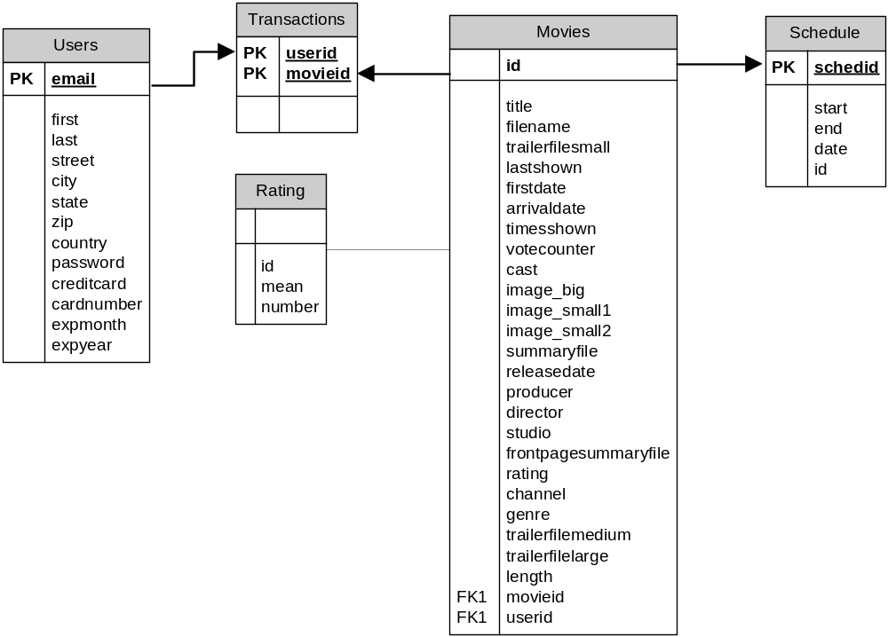Figure 2

Users
Field Name | Type | Description
Email | varchar(43) | Email address and  unique identifier
First | varchar(26) | First name
Last | varchar(26) | Last name
Street | varchar(52) | Street address
City | varchar(52) | City
State | varchar(52) | State
Zip | int(5) | Zip code
country | varchar(52) | Country
password | varchar(14) | Password
creditcard | varchar(14) | Credit card type
cardnumber | varchar(22) | Credit card number
expmonth | int(2) | Month card expires
expyear | int(4) | Year card expires

Movies
Field Name | Type | Description
Title | varchar(100) | Title of movie
filename | varchar(255) | Filename of full movie
trailerfilesmall | varchar(255) | Links to trailer at Apple's web site
lastshown | date(10) | Last date the movie was shown on
Firstdate | date(10) | First date the movie was shown.
arrivaldate | date(10) | Date of movie's arrival
timesshown | smallint(5) unsigned | Times the movie has been shown
votecounter | int(10) unsigned | Not used. Replaced by ratings table
id | int(10) unsigned not null auto_increment | Unique identifying number
cast | varchar(100) | Movie's principal cast
image_big | varchar(255) | Large publicity image
image_small1 | varchar(255) | Small publicity image
image_small2 | varchar(255) | Small publicity image
summaryfile | varchar(255) | Filename of summary text file
releasedate | date(10) | Date movie was released in theaters
producer | varchar(102) | Movie's producers
director | varchar(102) | Movie's directors
studio | varchar(102) | Production studio
frontpagesummaryfile | varchar(102) | Filename of short summary for front page
rating | varchar(6) | Movie's rating – G, PG, PG-13, R
channel | varchar(15) | Channel the movie should be listed under
genre | varchar(20) not null | Same as channel
trailerfilemedium | varchar(255) | Links to trailer at Apple's web site
trailerfilelarge | varchar(255) | Links to trailer at Apple's web site
length | int(10) | Length of movie in minutes

Rating
Field Name | Type | Description
id | int(4) not null | Movie id number
mean | int(1) | Mean value of votes
number | int(8) | Total number of votes

Schedule
Field Name | Type | Description
schedid | datetime(14) not null | Unique schedule id
start | time(8) | Time the movie starts
end | time(8) | Time the movie ends
date | date(10) | Date the movie is playing
id | int(10) unsigned | Movie id number

Transactions
Field Name | Type | Description
userid | varchar(43) | User's unique identifier
movieid | int(2) | Movie's unique identifier

APPENDIX B
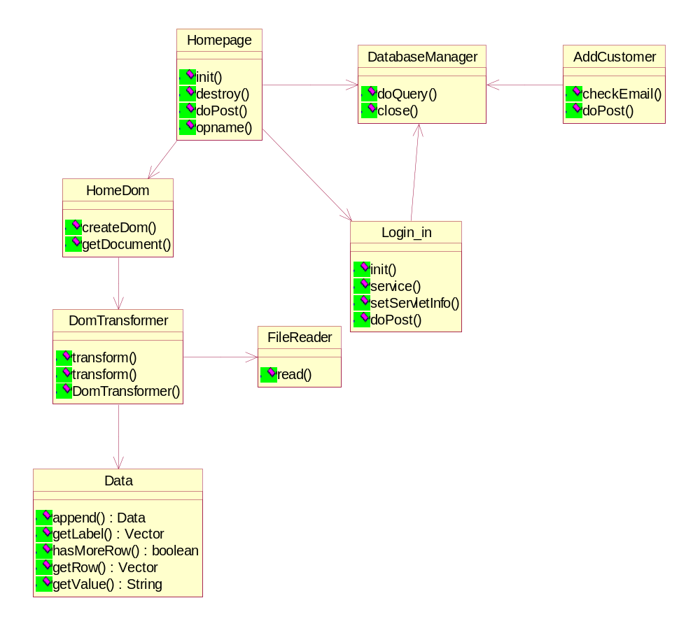
CLASS DIAGRAM

