CIS 764 –Project Report

E-Laundromat – An Online Dry Cleaning Service

By
Sushma Reddy Chitturi

Instructor: Dr. Bill Hankley
September 28, 2009.

INDEX Page Number
- Abstract 3
- Description 3
- Control Flow 3
- Database Model 3-4
- Use-Case Diagram 4-6
- Class Diagram 6-10
- Sequence Diagrams 11-12
- References 12

- Abstract

E-Laundromat is a simple web application developed to provide an online interface for handling the washing and drying needs of users which I developed as part of my class project during my undergrad. There are two kinds of users for this system, customers and administrators and roles for both these users we have clearly defined roles.

- Description
This web application will be used by customers who need to place an order for getting their clothes dry clean. Before then can do so they need to register with the website and after they have been successfully registered they can place their orders either by phone or mail or using this website. They can also do a search to know whether this service is available online or not in their area and if it is present they can place the order and after they have placed an order they can complete the order by making a payment. Every time an order is placed by the customer they gain some points and after they reach a limit they would be eligible to get some coupons which they can use to get some discounts on their next orders. There is also an admin for this website, who is responsible to handle the orders, users, customer’s points etc, He can perform and editing of the existing orders such as updating the order status, cancelling the orders etc,. He can also add new items to the available services list; view all the registered users’ information etc.

- ControlFlow
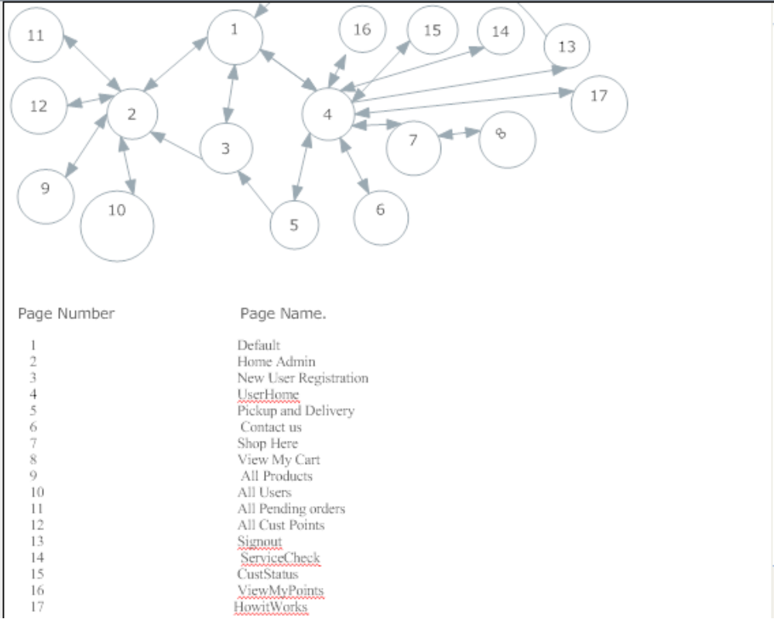

- Database Model.
The following figure gives a description of the database tables that are used in this application and the relationship between those tables.
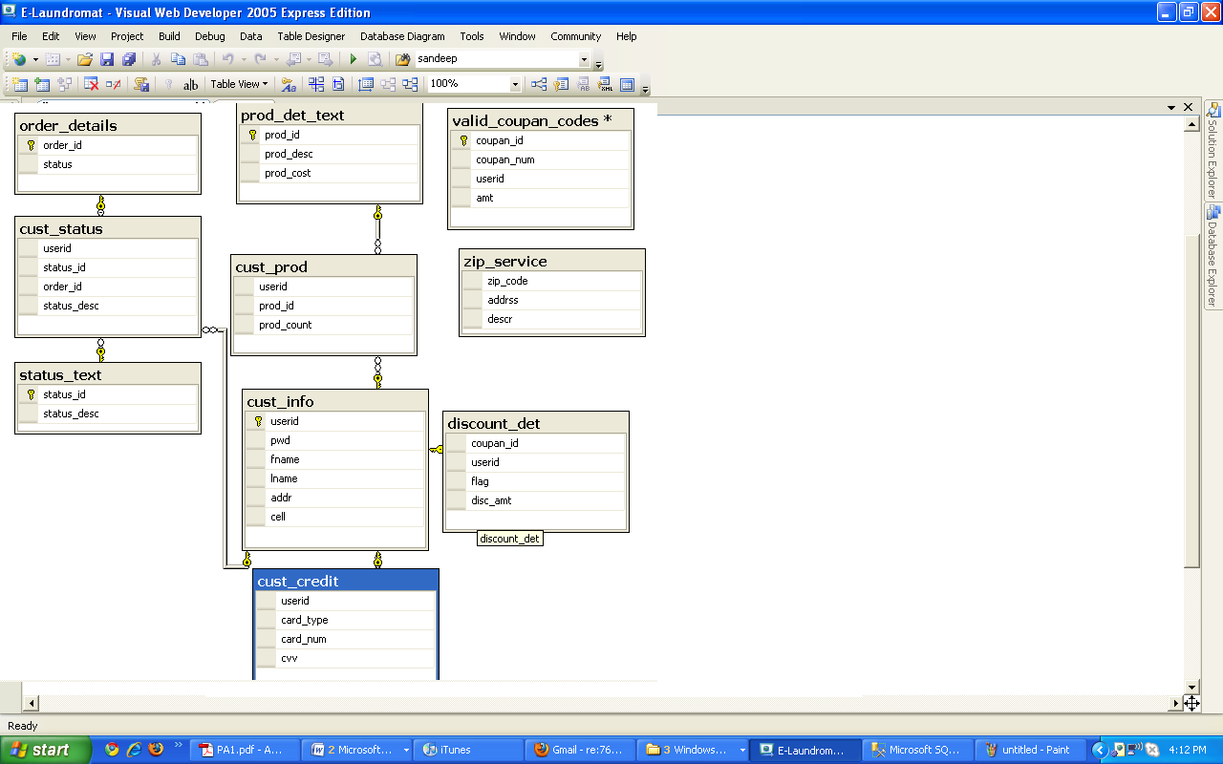
4.1. Translating database tables to user friendly names:
- cust_credit : User_CreditCard_Details.
- cust_info : User_Details
- cust_prod : User_Ordered_Merchandise
- cust_status : User_OrderStatus.
- order_details : User_Order_Details.
- prod_det_text : Merchandise_Details
- status_text : OrderStatus_Description
- valid_coupan_codes: Available_CouponCodes.
- zip_service: ServiceAvailableZipCodes.

- Use-Case Diagram: A Use case diagram is used to represent the actors involved in the system and their actions with the system. We have two kinds of actors in this system. First is the Customer and next would be the administrator.
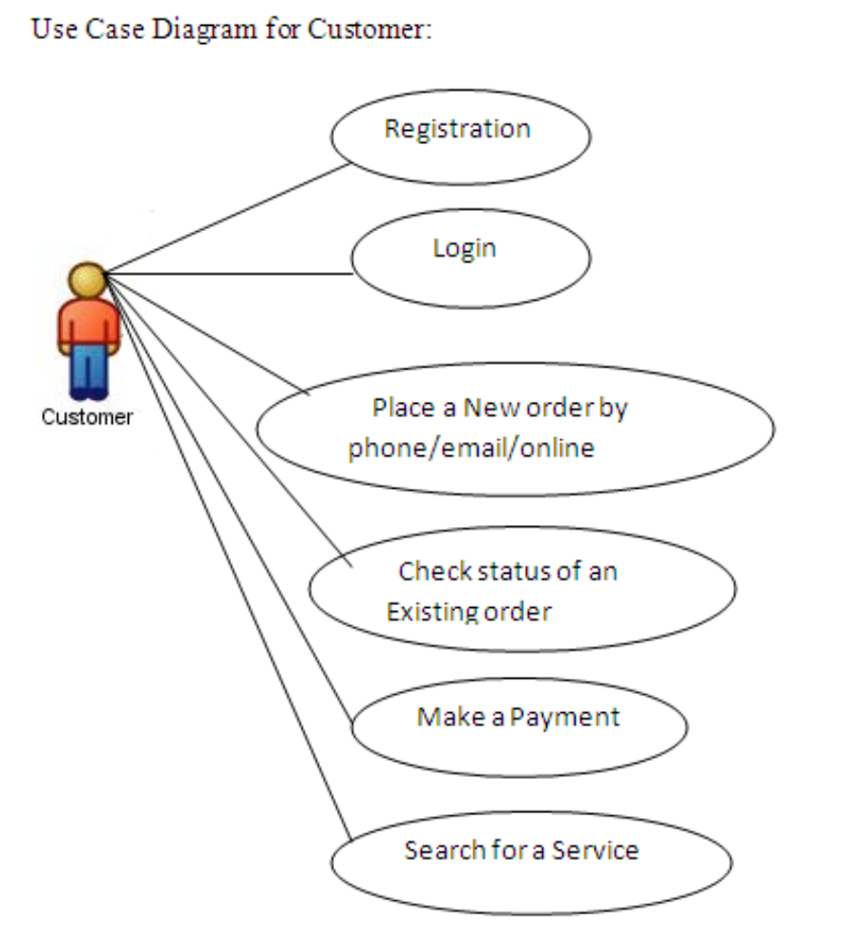

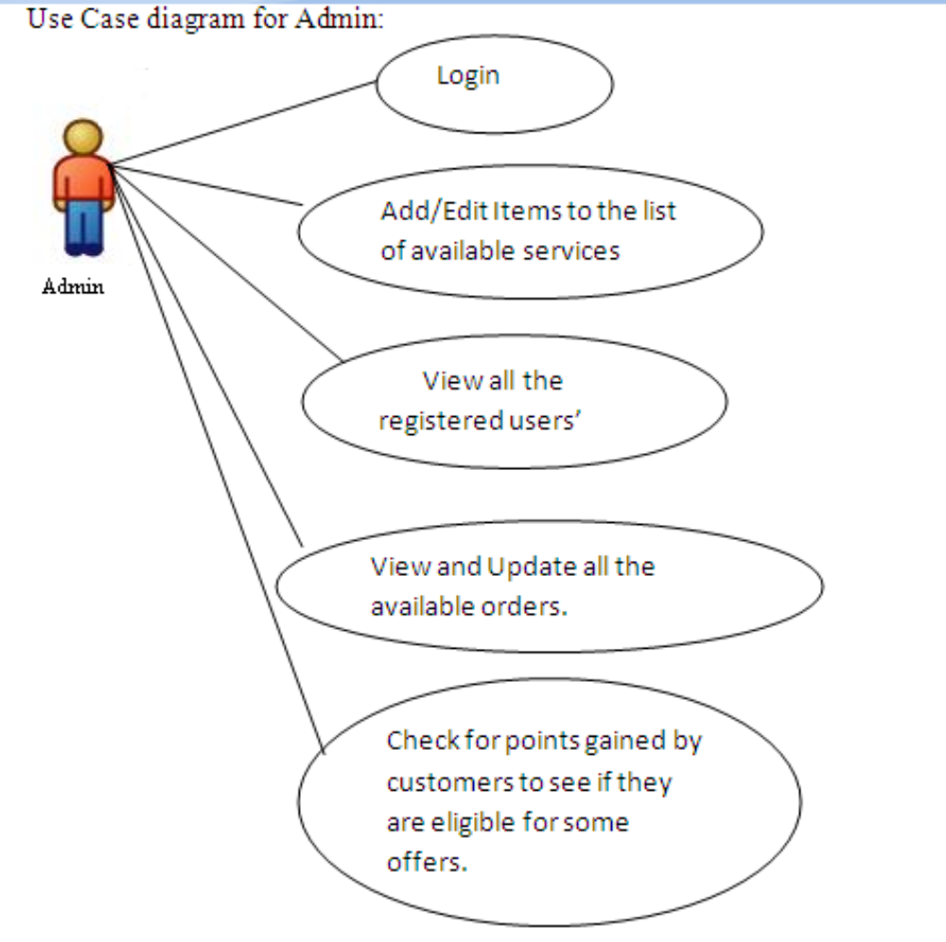
- Class Diagram: The class diagram is core to object-oriented design. It describes the types of objects in the system and the static relationships between them. Below is a simple class diagram for this application. I have also listed the database tables that each class uses to implement its responsibility/operations
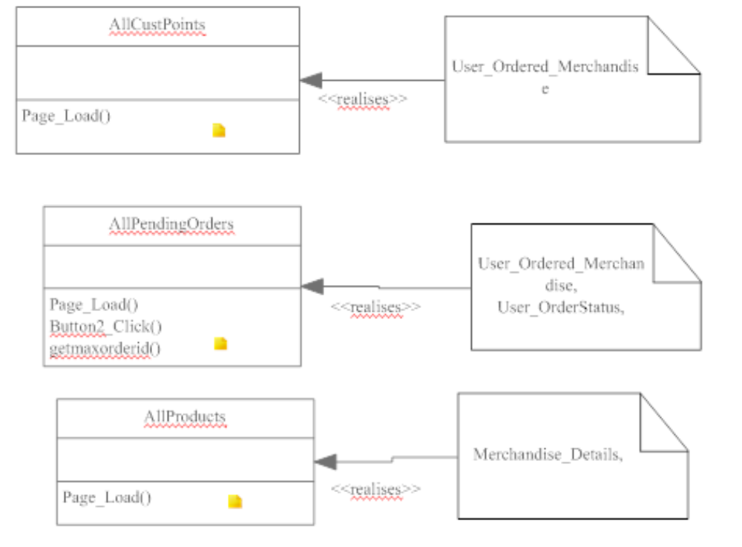
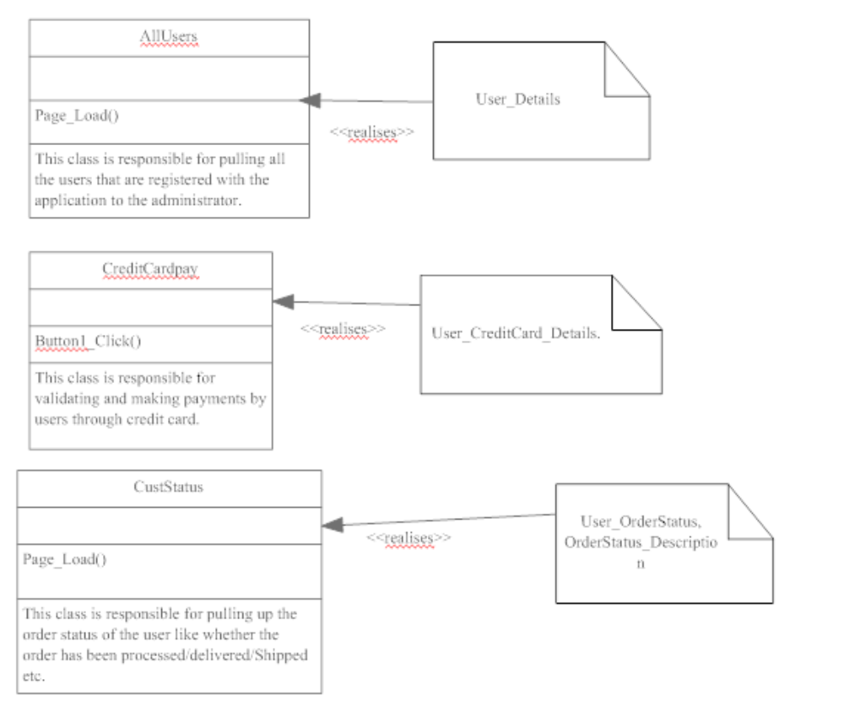.
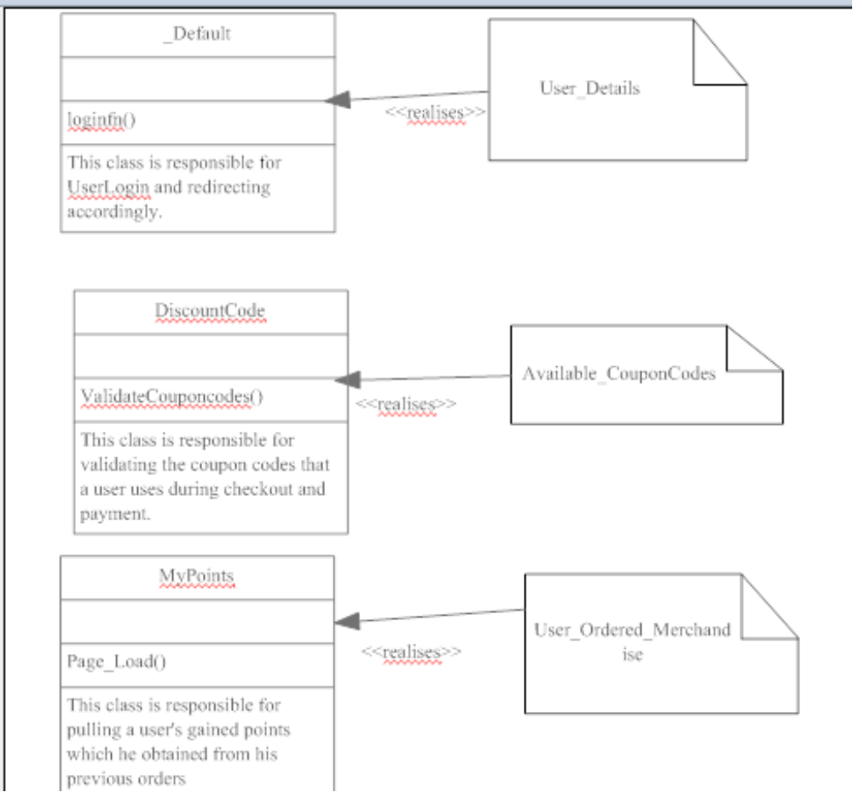
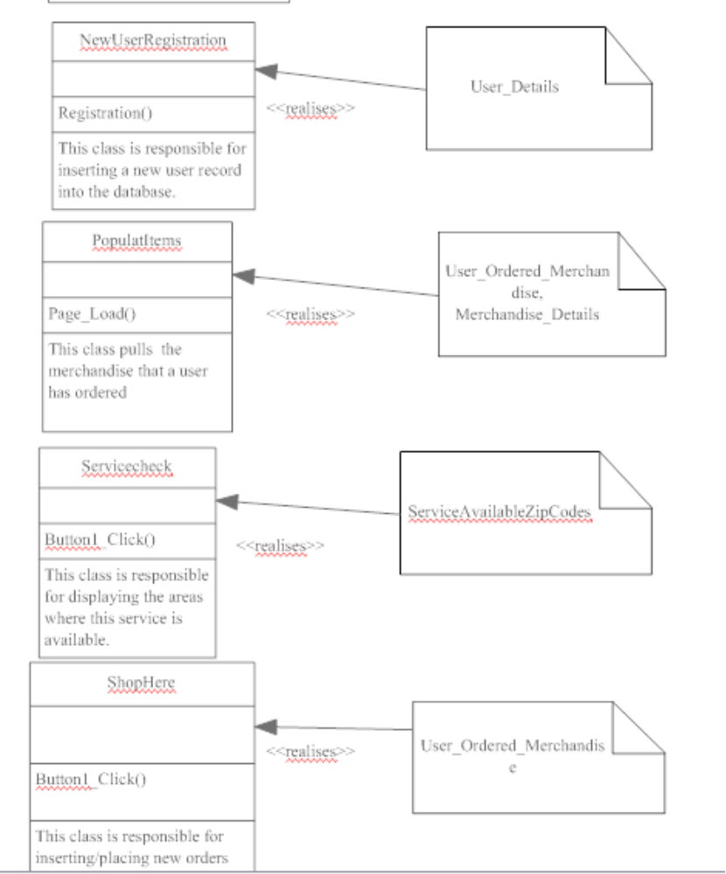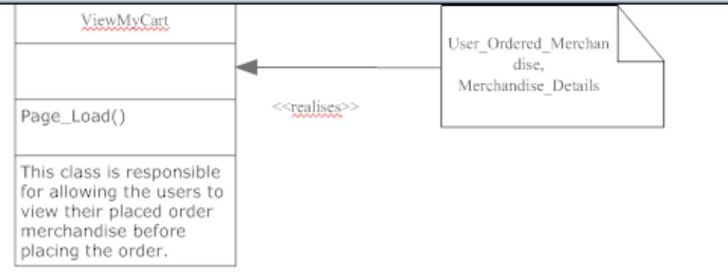

- Sequence Diagrams:
A Sequence diagram is a structured representation of behavior as a series of sequential steps over time. It is used to depict work flow, message passing and how elements in general cooperate over time to achieve a result.
A simple sequence diagram for registered/new customer would be as depicted below
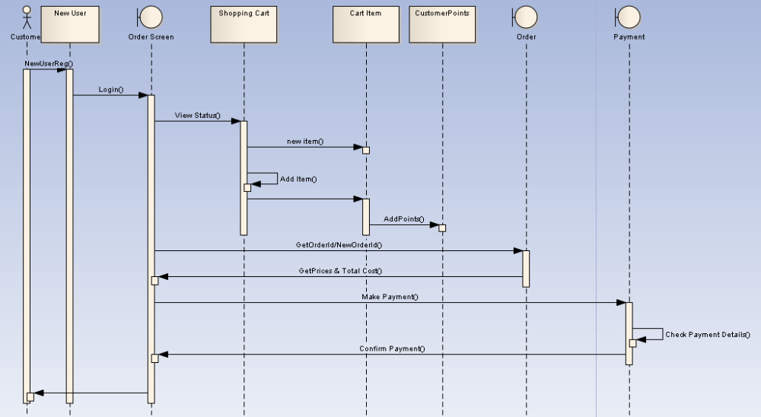
As we can see from the above figure that a customer before placing an order has to log-in to the system and if he is not a registered user he has to first register with the application and then log in to the system. After a successful login he can start making a new order or add/edit an existing order and after he is finished placing the order he makes a payment which is verified against a system and then after the payment has been approved his orders gets placed. This would be one of the main sequence of actions that a user does.
Below figure diagram depicts sequence of activities done by an Admin
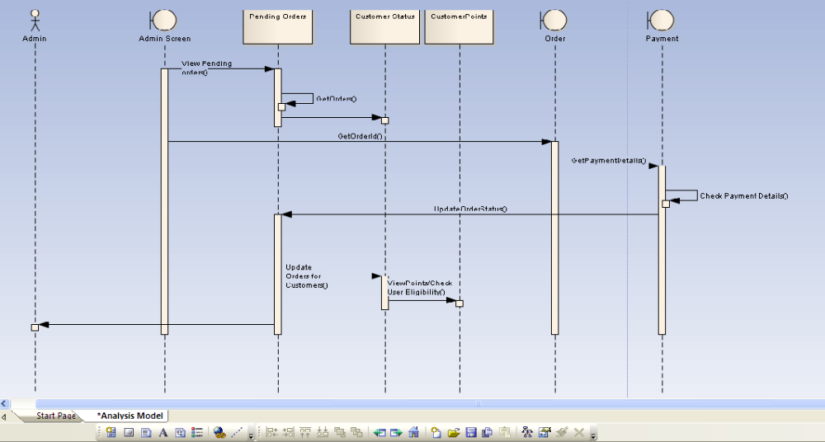
From the figure we can see a typical task of an administrator whose task is to update the order status of a customer. He does that by retrieving all the pending orders from the admin screen and for each pending order he gets the order details and also its payment details and checks for the payment details correctness and then updates the order status (for example from processed to shipped). He can also update the points scored by customers and notify any user if he/she is eligible for any offers

8) References:
- http://www.sparxsystems.com/downloads/whitepapers/Database_Modeling_In_UML.pdf
- http://www.sparxsystems.com.au/resources/uml_datamodel.html
- http://www.agiledata.org/essays/umlDataModelingProfile.html

